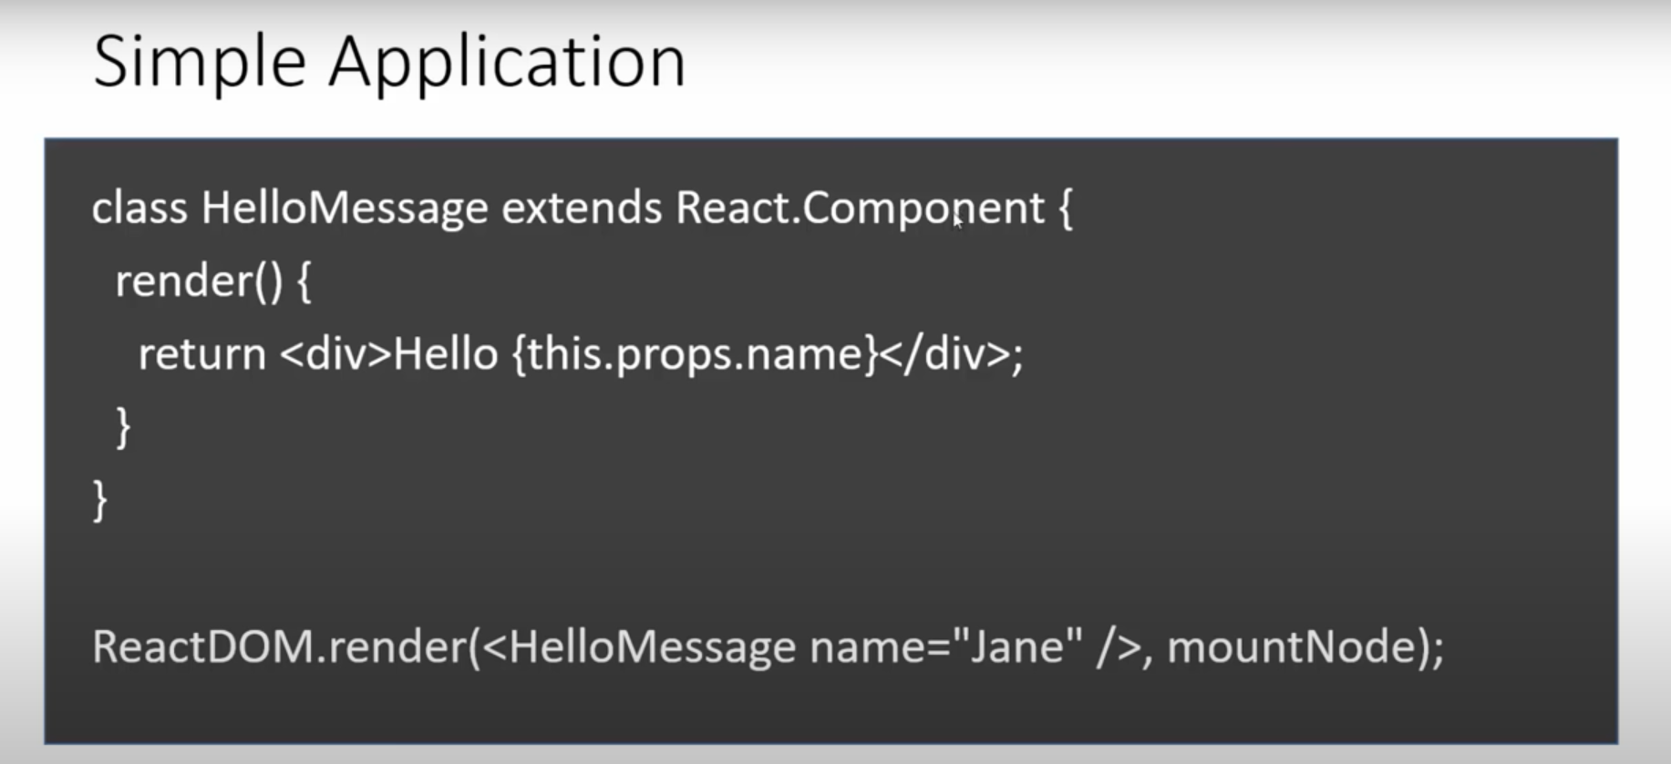

Here we have class called Hello message which extends React component.

Inside that we have function render, which is the only function required in a component.

After that we use return which is js syntax where this.props.name is component property

Last line we use ReactDOM to render it where we use name of component HelloMessage and passing in a property called name which is Jane for which we return it using this.props.name
And mountNode is where we want to insert the component in our html so we will have div for that with which id for that

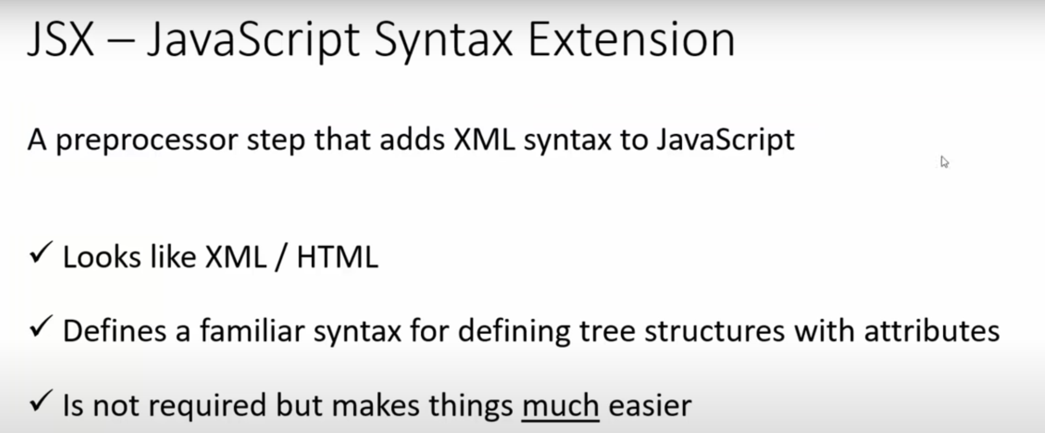
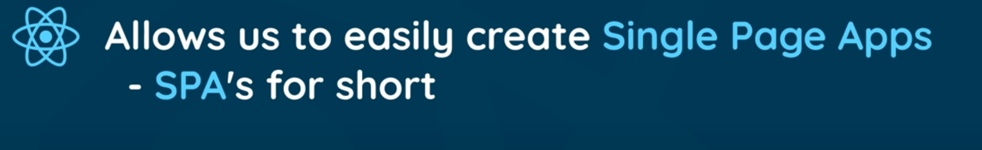

First install nodejs after that open a new terminal in vs code and run code:

npx create-react-app hello-world

Above code will create a new folder named “hello-world”

Other commands

npm start
Starts the development server.

npm test
Starts the test runner.

npm run eject
Removes this tool and copies build dependencies, configuration files
We suggest that you begin by typing:

cd hello-world
npm start

When you do npm start it will run in browser.

http://localhost:3000/

Edit src/App.js and save to reload. This message will appear in browser
So go to that location and edit

Add this part <div> Hello world</div>

When you save it it appears in browser

